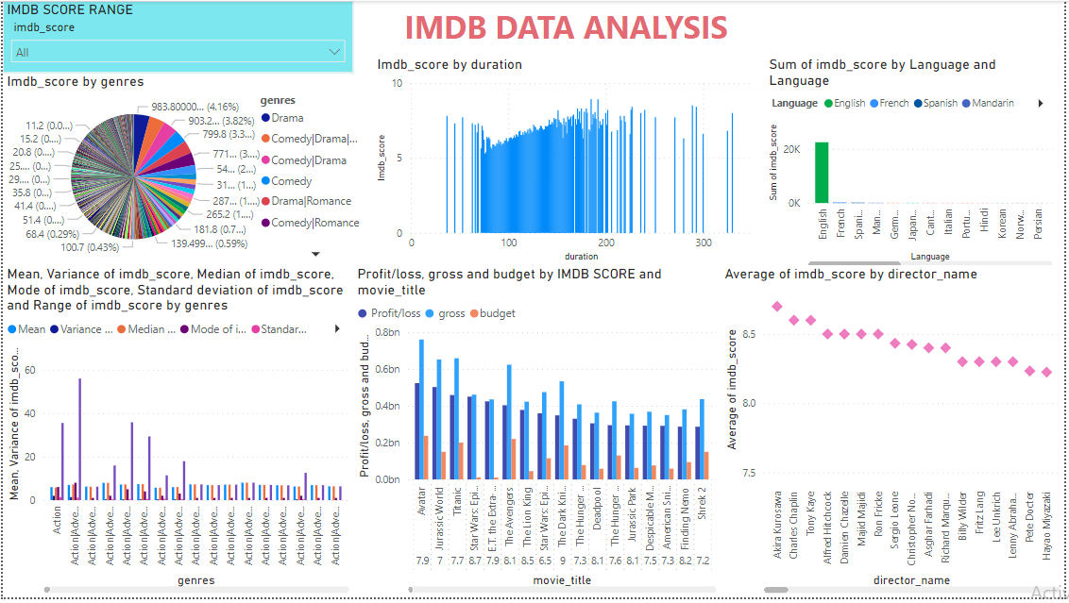

**IMDB SCORE VS Genres:**

* ﻿﻿Drama accounted for 4.16% of Imdb_score.﻿﻿ ﻿﻿ ﻿
* CRIME|DRAMA has the Highest IMDB SCORE of 9.3
* ﻿﻿﻿Mean and total Variance of imdb_score are negatively correlated with each other.﻿﻿ ﻿﻿
* ﻿﻿Comedy|Drama|Romance accounted for 3.97% of Mode of imdb_score.﻿﻿ ﻿﻿ ﻿﻿
* Across all 745 genres, Mean ranged from 2.10 to 8.50, Variance of imdb_score ranged from 0 to 5.49, and Median of imdb_score ranged from 2.10 to 8.50.﻿﻿ ﻿﻿ ﻿

**IMDB SCORE VS Duration:**

* ﻿﻿﻿185 and 192 minutes tied for highest Imdb_score at 8.90, followed by 289. 76 minutes had the lowest Imdb_score at 5.28.﻿﻿ ﻿
* ﻿ ﻿﻿Across all 151 duration, Imdb_score ranged from 5.28 to 8.90.﻿﻿ ﻿﻿ ﻿

**IMDB SCORE VS Language:**

* ﻿At 22,479.40, English had the highest Sum of imdb_score and was 5,22,676.74% higher than Bosnian, which had the lowest Sum of imdb_score at 4.30.﻿﻿ ﻿﻿
* ﻿﻿English had the highest Sum of imdb_score at 22,479.40, followed by French and Spanish. Bosnian had the lowest Sum of imdb_score at 4.30.﻿﻿ ﻿﻿ ﻿﻿
* English accounted for 95.16% of Sum of imdb_score.﻿﻿ ﻿﻿ ﻿﻿Across all 34 Language, Sum of imdb_score ranged from 4.30 to 22,479.40.﻿﻿ ﻿﻿ ﻿

**IMDB SCORE VS BUDGET, GROSS, PROFIT OR LOSS:**

* The Shawshank redemption has highest IMDB SCORE of 9.3 with the budget of 25000000 and gross of 28341469 with the profit of 3341469
* With IMDB SCORE 7.70 in movie_title Lady Vengeance  made up 3.23% of Profit. ﻿

**IMDB SCORE VS Director Name:**

* Director Fank Darabont has the highest IMDB SCORE 9.3
* Director John M Chu has the Least IMDB SCORE 1.6

**Conclusion:**

* After analysing the data the Language and Director plays the important role in IMDB Score.
* Even though All other factors are likely to influence the score but they all come after the above two criteria.